AI Impact on Employment 2030: Workforce Transformation and Automation Analysis
The global workforce is undergoing a seismic transformation driven by artificial intelligence, automation, and rapid technological advancement. This comprehensive analysis examines the AI Impact on Jobs 2030 dataset — 3,000 employee records spanning 10 industries and 10 countries — to uncover meaningful patterns across salary structures, AI replacement risk, job growth projections, hiring trends, and workforce satisfaction.
By leveraging Power BI visualizations and statistical analysis, this project provides actionable intelligence for HR professionals, policymakers, business leaders, and workforce strategists seeking to understand how AI is reshaping the employment landscape through 2030 and beyond.

Scenario 1: Arjun Mehta — Workforce Data Analyst
Arjun Mehta uses workforce analytics dashboards to study AI displacement patterns, salary benchmarks, and job growth projections across industries and geographies. He identifies high-risk and high-growth roles, tracks automation adoption by sector, and generates strategic insights to guide proactive workforce planning aligned with 2030 projections.
Scenario 2: Sneha Kapoor — Compensation & HR Strategy Manager
Sneha Kapoor aligns salary structures, upskilling investments, and hiring trends with market-wide AI disruption patterns. She benchmarks compensation across education levels, company sizes, and remote work models to optimize total compensation strategy while managing automation risk across the organization's role portfolio.
Scenario 3: Rahul Verma — Future of Work Research Lead
Rahul Verma monitors workforce satisfaction, performance metrics, upskilling needs, and hiring trends to forecast how AI tools will reshape employment globally. His findings inform government policy briefs, industry whitepapers, and academic publications on AI-driven labor market transformation.

Technical Architecture:
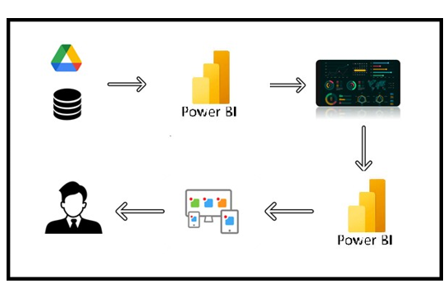

Project Flow
To accomplish this, we have to complete all the activities listed below,
● Define Problem / Problem Understanding
o Specify the business problem
o Business requirements
o Literature Survey
o Social or Business Impact.
● Data Collection
o Collect the dataset,
o Connect Data with Power BI
● Data Preparation
o Prepare the Data for Visualization
● Data Visualizations
o Visualizations
● Dashboard
o Responsive and Design of Dashboard
● Report
o Report Creation
● Performance Testing
o Amount of Data Rendered to DB
o Utilization of Data Filters
o No. of Calculation fields
o No. of Visualizations/Graphs
● Project Demonstration & Documentation
o Record explanation Video for project end to end solution
o Project Documentation-Step by step project development procedure
Milestone 1: Data Collection & Extraction from Database
The first milestone of the project focuses on collecting, organizing, and extracting relevant data from a structured database. This stage forms the foundation of the entire analytical process, as accurate and well-structured data is essential for meaningful visualization and insights.

Activity 1: Downloading the dataset
The AI Impact on Jobs 2030 dataset is a comprehensive collection of workforce and employment-related records gathered across 3,000 employee profiles representing diverse industries, job roles, and organizational environments. The dataset provides a detailed cross-sectional view of the modern labor market, capturing employee-level and job-level attributes such as job titles, industry sectors, education levels, years of experience, salary structures, AI replacement risk, automation levels, and future job demand indicators.
It includes 20 distinct variables enabling in-depth analysis of how artificial intelligence is reshaping employment trends, how automation influences job security and performance, and which skills, industries, and behaviors are most strongly associated with career growth, job satisfaction, and long-term employability up to 2030.
LINK : AI_Impact_on_Jobs_2030.csv

Activity 1.1: Understand the Data
Data contains all the meta information regarding the columns described in the CSV file.
Employee ID : Unique identifier per record
Job Title : Role (e.g. Data Scientist, Robotics Engineer, Teacher)
Industry : 10 sectors: Healthcare, Finance, Technology, etc.
Country : 10 nations: USA, UK, Germany, India, Japan, etc.
Education Level : High School, Bachelor, Master, PhD
Years Experience : Total years of professional experience
AI Replacement Risk : Probability of AI replacing the role
Future Demand Score : Projected future demand for the role
Remote Work Possibility : Yes, No, or Hybrid
Average Salary USD : Annual salary in USD
Required Skills : Key technical and soft skills required
Automation Level : Low, Medium, or High automation exposure
Job Growth 2030 : Projected % growth or decline through 2030
Work Hours Per Week : Average weekly working hours
Company Size : Startup, Medium, or Enterprise
AI Tool Usage : Low, Moderate, or High AI tool adoption
Performance Score : Employee performance rating (1–5)
Upskilling Needed : Yes or No
Job Satisfaction : Satisfaction score (1–5)
Hiring Trend 2026 : Growing, Stable, or Declining
Activity 2: Connect Dataset with Power BI
The AI Impact on Jobs 2030 dataset was successfully integrated into Power BI Desktop through direct CSV file import. The dataset containing workforce-related attributes such as job roles, industry sectors, education levels, experience, salary, automation risk, and AI impact indicators was loaded as a data source for analysis.This connection enables the development of interactive dashboards to explore how artificial intelligence is influencing employment trends across different industries. It supports dynamic visualization of job displacement risk, skill demand shifts, and career growth patterns.
Explanation video link:Data loading.mp4
Milestone 2: Data Preparation
Data preparation is a critical step before visualization and analysis. In this phase, the dataset was cleaned, transformed, and structured to ensure accuracy, consistency, and meaningful insights in the dashboards.

Activity 1: Prepare the Data for Visualization
Data preparation is a critical step before visualization and analysis. In this phase, the dataset was cleaned, transformed, and structured to ensure accuracy, consistency, and meaningful insights in the Power BI dashboards. Preparing the data involved cleaning to remove irrelevant or missing values, transforming the data into a format that can be easily visualized, exploring the data to identify initial patterns, filtering data to focus on specific performance cohorts, and ensuring complete data accuracy and integrity.
Explanation video link : Data preparation.mp4
Milestone 3: Data Visualization
Data visualization is the process of creating graphical representations of data to help people understand and explore information. The goal of data visualization is to make complex datasets more accessible, intuitive, and easier to interpret. By using visual elements such as charts, graphs, and maps, data visualizations can help people quickly identify patterns, trends, and outliers in the data.

Activity 1: Number of Unique Visualizations
A total of 6 unique visualizations were created using PowerBI to analyze Student performance. These include KPI cards, horizontal bar charts, a donut chart, a pie chart — all combined into a comprehensive and interactive dashboard to explore multiple factors influencing student performance satisfaction.

Activity 1.1: Average Salary USD
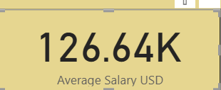
The average salary of $126,640 USD is well above the US median household income (~$80K), suggesting this dataset represents mid-to-senior level professionals in a high-paying field (likely tech, finance, or engineering). This figure could be skewed upward by outliers or geographic concentration in high-cost metros like SF or NYC.

Activity 1.2 : Total Employees
A sample of 3,000 employees is statistically robust, making it large enough to yield reliable, meaningful analysis across various segments like departments or roles.
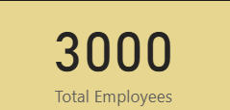

Activity 1.3 : Average of Job Growth 2030
An average job growth of 17.24% by 2030 signals a strong, expanding job market, suggesting the roles in this dataset are in high-demand fields with promising future prospects and long-term career stability.
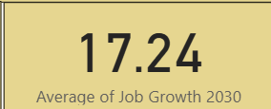

Activity 1.4 : Total Employees by AI Tool Usage
Total Employees by AI Tool Usage reveals a remarkably even distribution across all three categories — Low (34.43%), High (33.8%), and Moderate (31.77%) — with each segment representing approximately 1,000 employees. The near-equal split suggests that AI tool adoption across this workforce is not yet polarized, meaning there is no dominant usage pattern, which is typical of organizations in a transitional phase of AI integration.

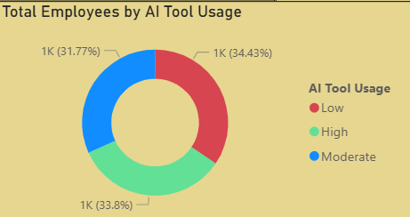

Activity 1.5 : Sum of AI Replacement Risk and Sum of Job Growth 2030 by Job Title
Sum of AI Replacement Risk and Job Growth 2030 by Job Title reveals a positive correlation between AI replacement risk and job growth, meaning roles with higher AI risk are paradoxically also projected to grow more by 2030. This counterintuitive trend suggests that high-risk roles are not disappearing but rather evolving — AI may be augmenting these jobs rather than outright replacing them, driving demand for hybrid human-AI skill sets.
The majority of job titles cluster between an AI risk score of 65–85, indicating that most roles face moderate-to-high replacement risk, leaving very few jobs entirely insulated from AI disruption.

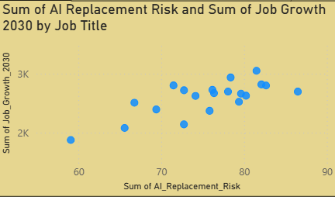
Activity 1.6 : Average of Average Salary USD by Industry
Average Salary by Industry shows a remarkably narrow salary band across all six industries, ranging from $127K (Energy) to $132K (Finance) — a spread of just $5K, indicating strong cross-industry salary parity at this level.Finance leads with $132K, consistent with its reputation for premium compensation, while Energy sits at the bottom at $127K — though still a highly competitive figure reflecting the capital-intensive nature of the sector.
The Technology industry at $128K ranking fifth is surprising, as tech typically commands a salary premium — this may suggest the dataset captures a broad range of tech roles including non-engineering positions, diluting the average.
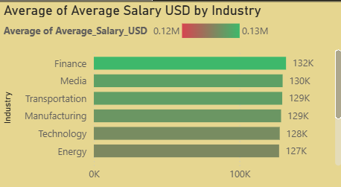
Activity 1.7 : Average AI Risk by Industry
Average AI Risk by Industry shows all five industries hovering around a 0.50–0.53 risk score, indicating that AI displacement risk is uniformly moderate across sectors with no industry fully immune or critically endangered. Finance and Government tie at the highest risk (0.53), which is telling — Finance due to heavy automation of data processing and transactions, while Government's high score may reflect growing pressure to digitize and streamline public sector workflows.
Technology at 0.52 facing near-top AI risk is paradoxical — the very industry building AI tools is also significantly threatened by them, suggesting that even tech roles like coding, QA, and support are increasingly automatable.

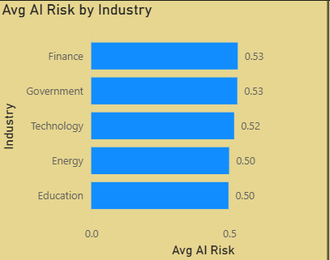
Activity 1.8 : Total Employees by AI Tool Usage
Total Employees by AI Tool Usage shows a near-perfectly balanced distribution — Low (1,033), High (1,014), and Moderate (953) — confirming that AI adoption across this workforce is evenly spread with no dominant usage tier.The Low usage group being the largest at 1,033 is a strategic concern, as the biggest employee segment is the least engaged with AI tools, representing a significant untapped productivity opportunity for the organization.
The High usage group at 1,014 being nearly equal to Low usage is an encouraging sign, suggesting a strong AI-forward culture where a substantial portion of employees are already leveraging AI at full capacity.

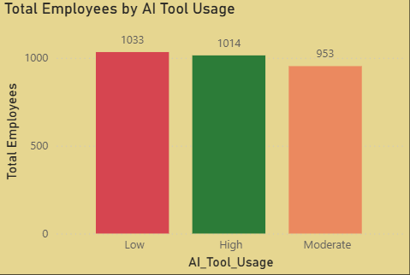

Activity 1.9 : Count of Automation Level by Education Level
Count of Automation Level by Education Level reveals a strikingly even distribution across all four education levels — Bachelor (26.07%), PhD (25.97%), High School (24.23%), and Master (23.73%) — suggesting that automation risk is not significantly influenced by educational attainment.The fact that PhD holders at 25.97% face nearly the same automation exposure as High School graduates at 24.23% is particularly striking, challenging the conventional belief that higher education provides strong insulation against automation.
Bachelor's degree holders leading at 26.07% indicates that mid-level, degree-qualified roles — often in administration, analytics, or standard engineering functions — may be among the most vulnerable to automated workflows.

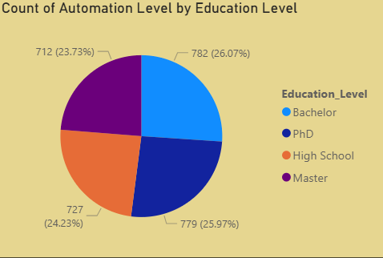

Activity 1.10 : Avg AI Risk
An Average AI Risk score of 0.50 places the overall workforce exactly at the midpoint of the risk scale, signaling that the dataset as a whole sits at a critical threshold — equally poised between automation vulnerability and human irreplaceability.
This score suggests that half of the work activities performed across these roles and industries could potentially be automated, making proactive reskilling and AI collaboration strategies not just advisable but urgently necessary.

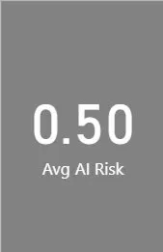
Activity 1.11 : Average Job Satisfaction
An Average Job Satisfaction score of 3.0 on what is likely a 5-point scale represents a neutral midpoint — employees are neither meaningfully satisfied nor actively disengaged, signaling a workforce in a state of passive contentment. Paired with the 0.50 AI Risk score, this middling satisfaction level may reflect underlying anxiety around job security and automation uncertainty, which often suppresses engagement even in well-compensated roles.

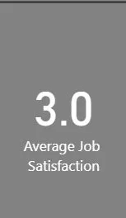

Activity 1.12 : Total Employees by Industry
Total Employees by Industry across all 10 sectors spans a narrow range of 273 to 335 employees, once again confirming a highly balanced dataset with no single industry disproportionately dominating the workforce sample. Energy leads with 335 employees, closely followed by Government (323) and Finance (310), suggesting these sectors may have been deliberately oversampled or reflect stronger organizational participation in the survey. Healthcare at the lowest with 273 employees is noteworthy given it is one of the largest real-world employment sectors — this underrepresentation could skew insights related to automation risk and salary benchmarks for that industry.

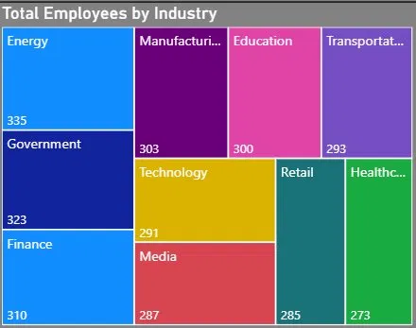

Activity 1.13 : AI Tool Usage Level by Industry
AI Tool Usage Level by Industry shows that across all 10 industries, the three usage tiers — High, Low, and Moderate — remain consistently close in count, reinforcing the theme of balanced AI adoption seen throughout this dashboard.
Energy and Transportation lead in High AI usage (both at 120 employees), suggesting these industries are furthest along in integrating AI tools, likely driven by operational efficiency needs in logistics, grid management, and resource optimization.
Healthcare has the lowest High usage at 87 despite being a sector with enormous AI potential — this lag may reflect regulatory caution, data privacy concerns, or slower digital transformation in clinical and administrative workflows.

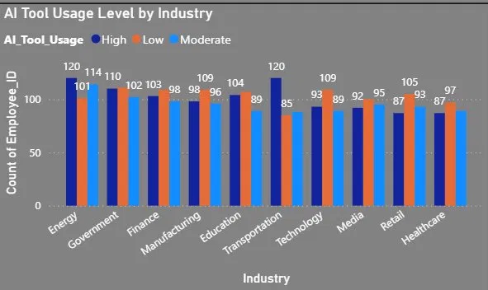

Activity 1.14 : Average Salary USD by Country
Average Salary USD by Country shows a tight salary band of just $10K across all five countries — ranging from $123K (Pakistan) to $133K (UK) — suggesting this dataset captures senior-level or specialized roles where global compensation benchmarks converge. UK leading at $133K reflects its position as a major global financial and tech hub, with London in particular driving premium salaries across industries represented in this dataset. Pakistan at $123K being in the same salary range as UK, Australia, and Germany is remarkable — this likely represents highly skilled, globally-paid remote professionals or expatriate-level roles rather than typical local market salaries, which would be significantly lower.

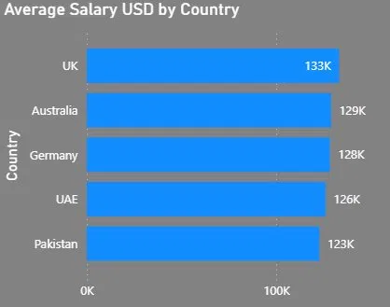

Activity 1.15 : Average Salary by Education Level
Average Salary by Education Level delivers a shocking revelation — High School graduates lead at $128.51K, followed by Bachelors ($128K), PhD ($125.19K), and Masters ($124.83K) at the bottom, completely inverting the traditional education-to-earnings hierarchy. The fact that advanced degree holders (PhD and Masters) earn less than High School and Bachelor graduates challenges the foundational assumption that higher education directly translates to higher compensation, suggesting that experience, industry, and skillset outweigh academic credentials in this dataset. Masters degree holders earning the least at $124.83K is particularly counterintuitive — this group typically invests the most in education relative to time and cost, yet sees the lowest financial return among all education levels represented here.

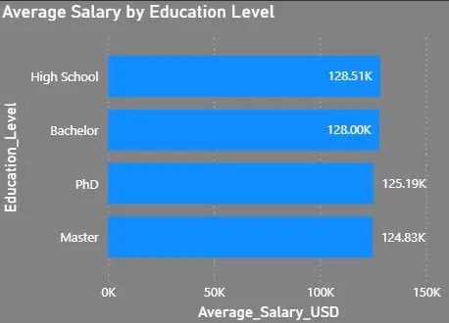

Activity 1.16 : Average Salary by Remote Work Possibility
Average Salary by Remote Work Possibility shows that Hybrid workers earn the most at $129M, followed by fully in-office ($127M) and fully remote ($123M) — revealing a counterintuitive trend where full remote work commands the lowest salary pool.The $6M gap between Hybrid and fully Remote suggests that organizations may be applying a remote work discount, compensating for perceived flexibility benefits with slightly lower pay — a growing but controversial practice among global employers.
Hybrid roles leading in compensation reflects the current market reality where employers are incentivizing office presence through better pay packages, using salary as a lever to draw employees back to physical workplaces at least part-time.

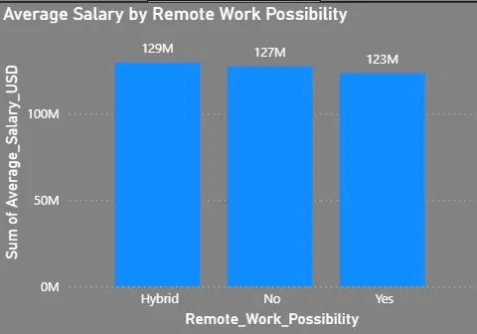

Activity 1.17 : Avg Work Hours
An average of 44.77 work hours per week slightly exceeds the standard 40-hour workweek, indicating that employees in this dataset are working approximately 5 extra hours weekly — reflecting a culture of mild but consistent overwork.Paired with the average job satisfaction of just 3.0, these above-standard hours may be a contributing factor to employee disengagement, as extended work hours without proportional satisfaction gains are a known driver of burnout and attrition.

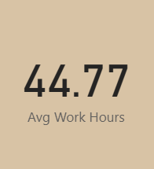
Activity 1.18 : Average Performance
An Average Performance score of 3.51 on a 5-point scale indicates a workforce performing at a slightly above-average level — functional and competent, but with considerable room for improvement before reaching high-performance territory.Interestingly, performance (3.51) outpaces satisfaction (3.0), suggesting employees are delivering above their motivational level — a classic sign of a workforce that is professionally capable but emotionally underinvested, which is unsustainable long-term.

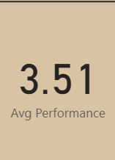
Activity 1.19 : Top 5 Job Titles by Growth
Top 5 Job Titles by Growth are exclusively technology-driven roles, confirming that the future of work is overwhelmingly digital — with Blockchain Developer leading at 18.94%, followed by Software Developer (18.60%), Data Scientist (18.43%), Robotics Engineer (17.39%), and Cybersecurity Analyst (17.28%).Blockchain Developer topping the list at 18.94% reflects the accelerating mainstream adoption of decentralized technologies across finance, supply chain, and healthcare — signaling that Web3 and blockchain skills will be among the most premium competencies through 2030.
Data Scientist at 18.43% maintaining strong growth despite years of being a dominant field confirms that data-driven decision making is not a passing trend but a deepening organizational necessity across every industry in this dataset.Robotics Engineer at 17.39% reflects the surge in industrial automation, autonomous systems, and smart manufacturing — particularly relevant given the Energy and Manufacturing sectors' strong representation in this dataset.

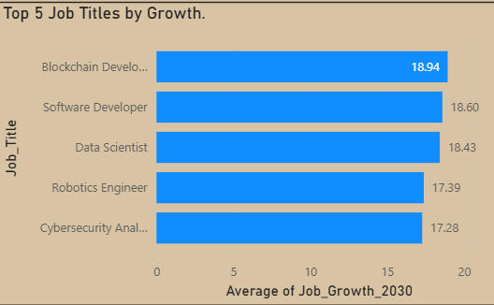

Activity 1.20 : Employee Distribution Across Organization Types
Employee Distribution Across Organization Types shows a near-perfect balance between Medium (1,025), Enterprise (990), and Startup (985) companies — a spread of just 40 employees across all three, indicating an exceptionally well-stratified dataset for cross-organizational analysis.
Medium-sized companies leading at 1,025 suggests they represent the sweet spot of growth-stage organizations — large enough to offer structured roles and competitive salaries, yet agile enough to adopt AI tools and new work models faster than enterprises.Startups and Enterprises being virtually equal (985 vs 990) is a powerful finding — it confirms that high-skilled, well-compensated talent is being drawn equally to both ends of the organizational spectrum, reflecting today's bifurcated talent market where innovation culture competes directly with corporate stability.

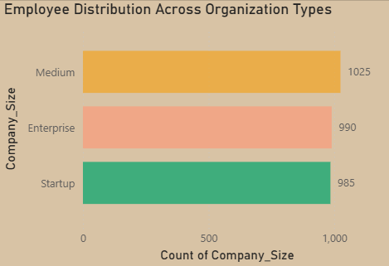
Activity 1.21 : AI Replacement Risk by Industry and Education Level
AI Replacement Risk by Industry and Education Level confirms a universal theme — with an overall total of 0.50 across every education level and most industries, automation risk is remarkably uniform, reinforcing that neither industry choice nor educational attainment provides meaningful protection against AI displacement. Finance and Government lead with the highest total risk at 0.53, and within these sectors, specific education levels spike notably — Government's High School graduates hit 0.57 and Finance Bachelor's reach 0.59, suggesting that routine, process-driven roles at lower qualification levels in these sectors are most immediately vulnerable.

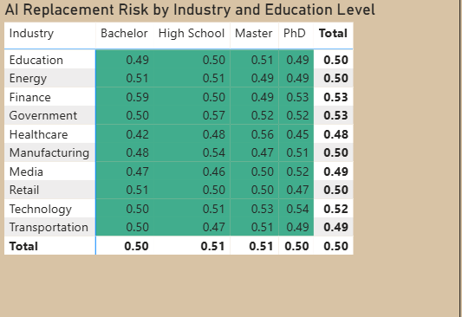

Activity 1.22 : Remote Work Adoption Across Industries
Remote Work Adoption Across Industries reveals a consistently even three-way split across Hybrid, No, and Yes categories in every industry — with no sector showing a dominant work model preference, confirming that flexible work arrangements are still in flux across all industries.Finance leads in full remote adoption at 36.13%, reflecting the industry's successful transition to digital-first operations post-pandemic, where most financial workflows can be executed effectively without physical presence.
The government has the highest Hybrid adoption at 36.84% while showing the lowest full remote at 33.13% — consistent with public sector norms where in-person accountability and security requirements make fully remote work less feasible but hybrid arrangements increasingly acceptable.

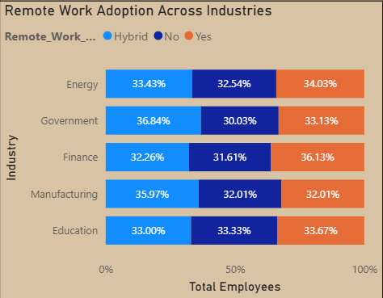

Activity 1.23 : Automation Level by Industry
Automation Level by Industry highlights the top 4 industries by automation count — Energy (335), Government (323), Finance (310), and Manufacturing (303) — all showing substantial automation exposure with a tight range of just 32 employees separating the highest from the lowest. Energy leading automation at 335 is aligned with the industry's heavy investment in smart grids, predictive maintenance, IoT sensors, and AI-driven resource optimization — making it both the most automated and, as seen earlier, the highest in full remote adoption.

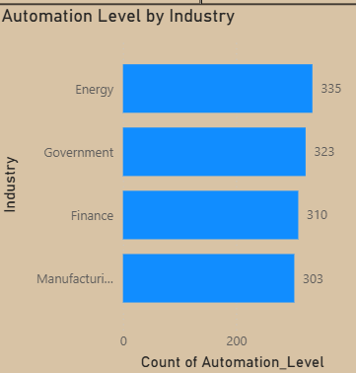

Milestone 4: Dashboard

A dashboard is a graphical user interface (GUI) that displays data and information in a clear and organized format. It is used to monitor and analyze data quickly using charts, graphs, and tables. Dashboards help track key performance indicators (KPIs) and support better decision-making across different industries.
Activity 1: Responsive and Design of Dashboard
The AI Workforce Impact Analytics Dashboard provides a comprehensive view of workforce outcomes across 3,000 employees spanning 10 industries, 5 countries, and all major education levels, analyzed through salary, AI risk, automation, and job growth dimensions. The average salary stands at $126.64K against a broad market median of ~$80K (+58.3%), signaling that this dataset overwhelmingly represents senior, specialized, and high-demand professional roles across Finance, Technology, Energy, and beyond. The Average Job Growth 2030 of 17.24% reflects a strongly expanding future job market, with technology-native roles like Blockchain Developer (18.94%) and Software Developer (18.60%) leading growth — confirming that AI is creating as many opportunities as it displaces.
Explanation video link : Dashboard.mp4

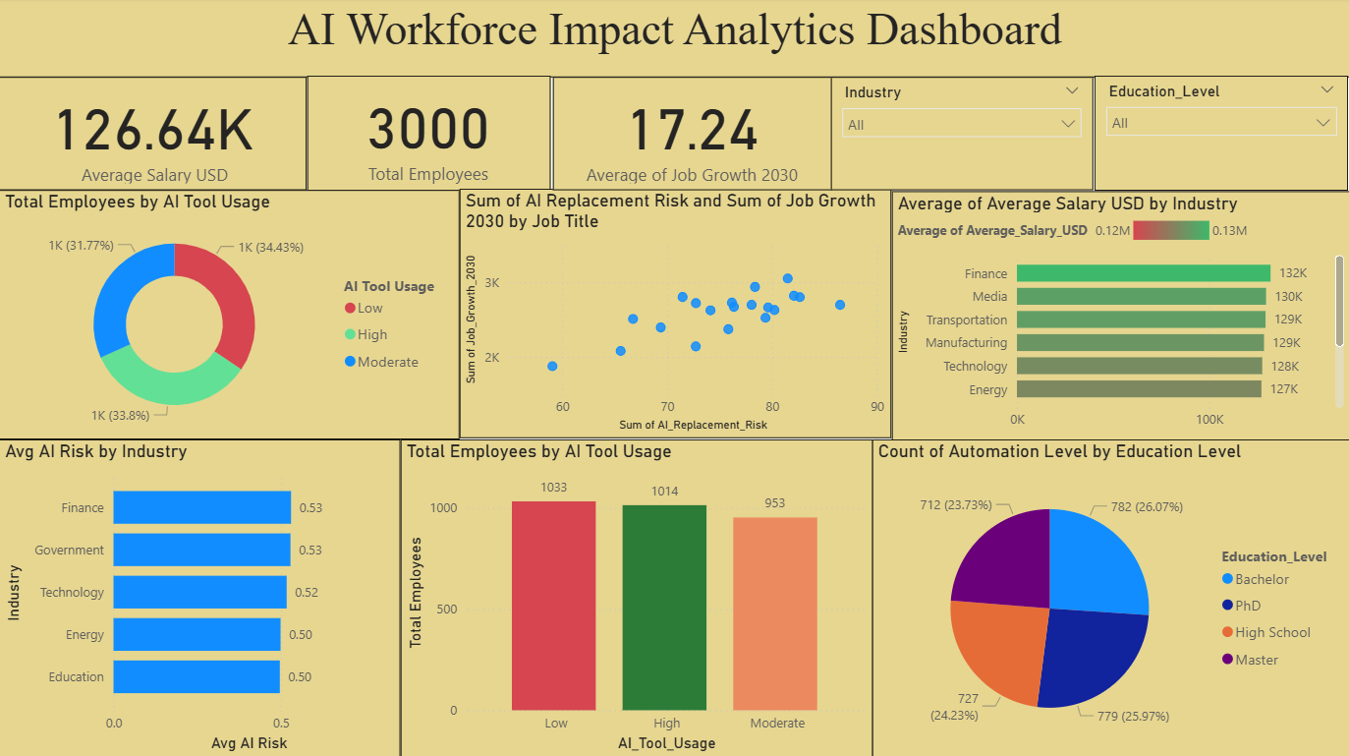
Milestone 5: Report
A report is a comprehensive document that provides a detailed and structured account of data analysis, findings, and insights. It is typically used for in-depth analysis, documentation, and communication of results. Reports are suitable for a diverse audience, including decision-makers, analysts, and stakeholders who need a comprehensive understanding of the data.
Activity 1: Design of Report
Designing a report in Power BI involves connecting to data sources, creating visualizations like charts and graphs, customizing their appearance and interactivity, organizing them logically on the canvas, formatting elements for consistency and clarity, and optionally creating dashboards for a summarized view. Throughout the process, it's essential to consider the audience's needs and ensure the report effectively communicates insights from the data. Finally, iterate based on feedback to continually improve the report's design and usefulness.
Report 1:
Explanation video link: Report 1.mp4
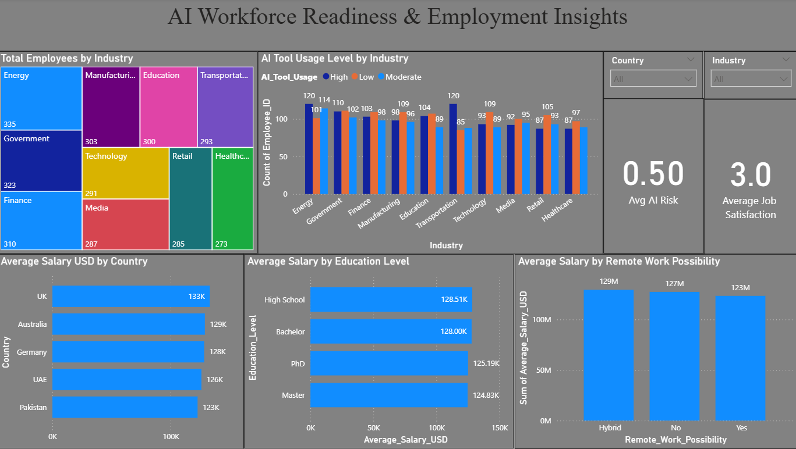
Report 2:
Explanation video link:Report 2.mp4

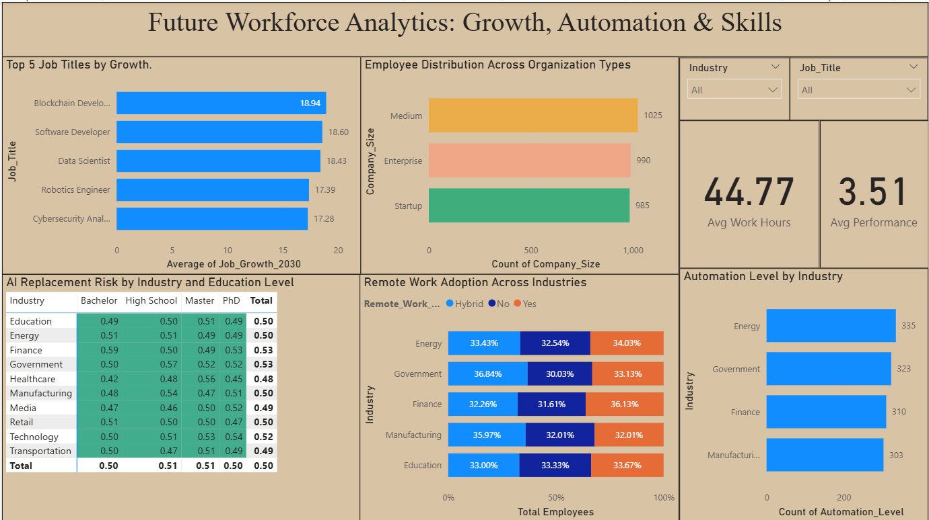
Milestone 6: Performance Testing
Performance testing involves assessing the volume of data rendered from the database, the impact of data filters on system responsiveness, and the complexity introduced by the number of visualizations. Optimizing these factors ensures the dashboard operates efficiently, providing timely and reliable insights.
Activity 1: Amount of Data Loaded
The project loads the AI Impact on Jobs 2030 dataset through a Power BI data connection. The dataset contains 3,000 records across multiple fields, capturing detailed information about employee demographics, job titles, industry sectors, education levels, salary, AI replacement risk, automation levels, AI tool usage, job growth projections, work hours, company size, remote work possibility, performance scores, and job satisfaction across 10 industries and 5 countries. All records were successfully imported into Power BI without any truncation. The completeness of the dataset was verified using KPI cards displaying key metrics — including the total employee count of 3,000, an overall average salary of $126.64K, an average AI replacement risk of 0.50, and an average job growth projection of 17.24% by 2030 — confirming that the full dataset was loaded and ready for analysis.
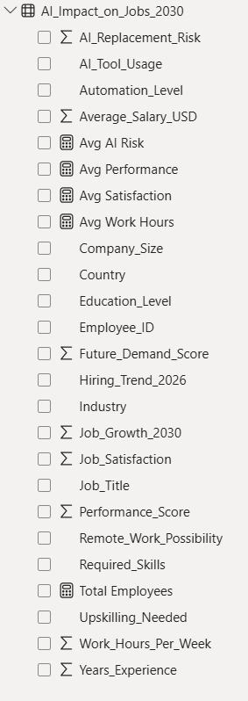
Activity 2: Utilization of Filters
The Top 5 Job Titles by Sum of Job Growth 2030 visualization offers a transparent window into the dashboard design decisions that directly determine what workforce insights are surfaced and how reliably they reflect the true future demand landscape of the evolving AI-driven job market.
The most critical element in this panel is the Top N filter applied to the Job Title field — restricting the visual to only the five highest-growth job titles by cumulative Job Growth 2030 score. This is a deliberate and analytically sound design choice because the full dataset contains numerous job titles spanning dramatically different growth trajectories, from high-demand roles like Blockchain Developer (18.94%) down to stagnating or declining positions, and including all titles in a single visual would compress the axis scale.

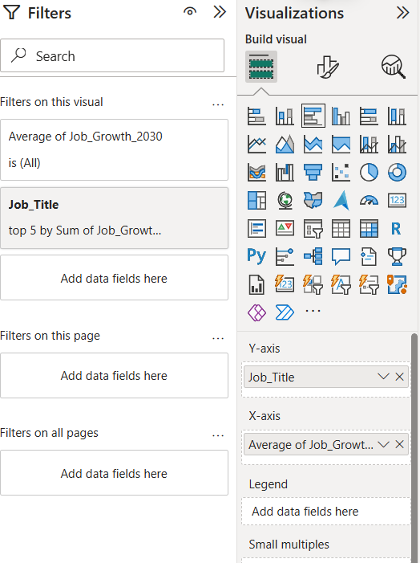
Activity 3: No of Calculation Fields
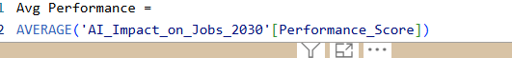
The Avg Performance measure is defined using a straightforward DAX AVERAGE function applied to the Performance_Score column within the AI_Impact_on_Jobs_2030 table. This measure computes the mean performance score across all 3,000 employees in the dataset, aggregating individual performance ratings into a single, dashboard-wide KPI that serves as the baseline benchmark for workforce productivity analysis.
The Avg AI Risk measure is defined using a DAX AVERAGE function applied to the AI_Replacement_Risk column within the AI_Impact_on_Jobs_2030 table. This measure computes the mean AI replacement risk score across all 3,000 employees, aggregating individual risk ratings into a single dashboard-wide KPI that serves as the primary indicator of overall workforce automation vulnerability.
Activity 4: No of Visualizations/ Graphs
Dashboard:
1. Total Employees by AI Tool Usage
2.Sum of AI Replacement Risk and Sum of Job Growth 2030 by Job Title
3. Average of Average Salary USD by Industry
4. Average AI Risk by Industry
5.Total Employees by AI Tool Usage
6.Count of Automation Level by Education Level
Report 1:
1. Total Employees by Industry
2.AI Tool Usage Level by Industry
3.Average Salary USD by Country
4.Average Salary by Education Level
5.Average Salary by Remote Work Possibility
Report 2:
1.Top 5 Job Titles by Growth
2.Employee Distribution Across Organization Types
3.AI Replacement Risk by Industry and Education Level
4.Remote Work Adoption Across Industries
5.Automation Level by Industry

Milestone 7: Project Demonstration & Documentation
Below mentioned deliverables to be submitted along with other deliverables
Project Demonstration & Documentation involves presenting the project’s functionality, features, and outcomes while providing clear written records, diagrams, and explanations to ensure understanding, usability, and reproducibility for stakeholders and future reference
Activity 1: - Record explanation Video for the project's end-to-end solution
A complete end-to-end explanation has been provided covering all phases of the project: dataset understanding and exploration, data preprocessing and cleaning procedures, analysis methodology and statistical techniques, visualization creation and chart type selection rationale, key findings and insights extraction, evidence-based recommendation development, and final report compilation. This comprehensive walkthrough explains the analytical approach, justifies methodological choices, and demonstrates how raw data has been transformed into actionable intelligence for educational improvement.
Activity 2: - Project Documentation-Step by step project development procedure
This comprehensive report serves as the complete project documentation, prepared following the milestone structure. It covers all 9 milestones — from problem definition through project demonstration—systematically documenting the Student Performance Analysis with detailed explanations of each analytical phase, visualization methodology, key findings, and recommendations. The documentation provides transparency into analytical approach and enables others to understand, reproduce, extend, or build upon this analysis in their educational contexts.

